
BUS

ANL252

PYTHON FOR DATA ANALYTICS

Tutor-Marked Assignment

July 2022 Presentation

Submitted by:

Name | PI No.
TAN BOON MAY (CHEN WENMEI) | W2210814

Submission Date: 14/08/2022

Question 1A – CHART 1

Total no of staffs resigned since 2010

Unit | Count of ID
Engineering | 4
IT | 7
Manufacturing | 71
Sales | 3

Question 1A – CHART 2

DATA REFLECTING THE GENDER OF RESIGNED STAFFS FROM MANUFACTURING DEPT

Age Ranges | Females | Males | Total
31 - 34 | 6 | 3 | 9
35 - 39 | 14 | 7 | 21
40 - 44 | 5 | 5 | 10
45 - 49 | 4 | 7 | 11
50 - 54 | 7 | 4 | 11
55 - 59 | 2 | 0 | 2
60 - 64 | 0 | 2 | 2
65 - 69 | 3 | 0 | 3
70 + | 2 | 0 | 2
 |  | Total | 71

Basic filter function has been applied on the data received. The number of resigned staffs from Manufacturing department is quite prominent. Therefore, more in-depth analysis is targeted in this area. The filter function and other Excel formulas have helped to provide additional information: -

- In terms of salary scales, resigned staffs from Manufacturing department are the bottom 72% among all.
- In terms of performance, only 10 out of 71 resigned staffs from Manufacturing department have not met the working requirements
- There is no obvious trend relating to the year of service for Manufacturing. (i.e <4 yrs = 34 resigned staff; <11 yrs = 37 resigned staffs).
- The age of all resigned staffs from Manufacturing is range from 31 to 71 years old.
- The second chart has demonstrated the number of female resigned staffs are higher than the male.

Deduced from the information obtained, the working environment and job scopes may be more challenging for females of middle aged and above. Also, the salary scale may not have enough retaining power resulting in high resign rate from Manufacturing department.

Question 1B – CHART 1

(IPYNB file reference :-
"C:\Users\user\OneDrive - SUSS University\SUSS\ANL252\TMA_ANL252_Tan Boon May_ W2210814_QUESTION 1(B) Part 1 (final).ipynb")

Total no of staffs resigned since 2010

import pandas as pd
data = pd.read_csv (r'C:\Users\user\OneDrive - SUSS University\SUSS\ANL252\TMA_Data_Manufacturing.csv')
data.head()

import numpy as np
import matplotlib.pyplot as plt

# creating the dataset
data = {'Engineering':4, 'IT':7, 'Manufacturing':71,
'Sales':3}
department = list(data.keys())
resignees = list(data.values())

fig = plt.figure(figsize = (10, 10))

# creating the bar plot
plt.bar(department, resignees, color ='lightblue',
width = 0.4)

plt.xlabel("Department")
plt.ylabel("No of Resignees")
plt.title("Resignees since 2010")
plt.show()
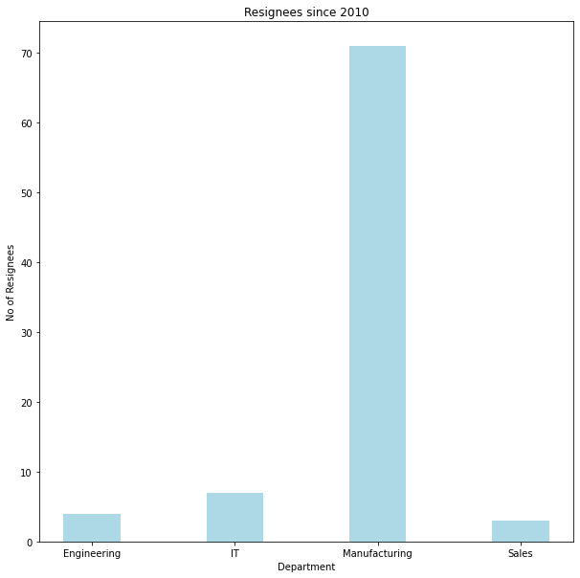

Question 1B – CHART 2

(IPYNB file reference :-
"C:\Users\user\OneDrive - SUSS University\SUSS\ANL252\TMA_ANL252_Tan Boon May_ W2210814_QUESTION 1(B)_part 2 (final).ipynb")

DATA REFLECTING THE GENDER OF RESIGNED STAFFS FROM MANUFACTURING DEPT

import pandas as pd
data = pd.read_csv (r'C:\Users\user\OneDrive - SUSS University\SUSS\ANL252\TMA_Data_Q1b_part2.csv')
data.head()

import numpy as np
import matplotlib.pyplot as plt

# create data
x = ['31-34', '35-39', '40-44', '45-49', '50-54', '55-59', '60-64', '65-69', '70+']
females = (6, 14, 5, 4, 7, 2, 0, 3, 2)
males = (3, 7, 5, 7, 4, 0, 2, 0, 0)
fig = plt.figure(figsize = (15, 10))

# plot bars in stack manner
plt.bar(x, females, color='lightblue', width = 0.8)
plt.bar(x, males, bottom=females, color='orange', width = 0.8)
plt.xlabel("Age Ranges")
plt.ylabel("No of Resignees")
plt.title("Gender of total resigned staffs from Manufacturing Dept")
plt.legend(["Females","Males"])

plt.show()

plt.show()

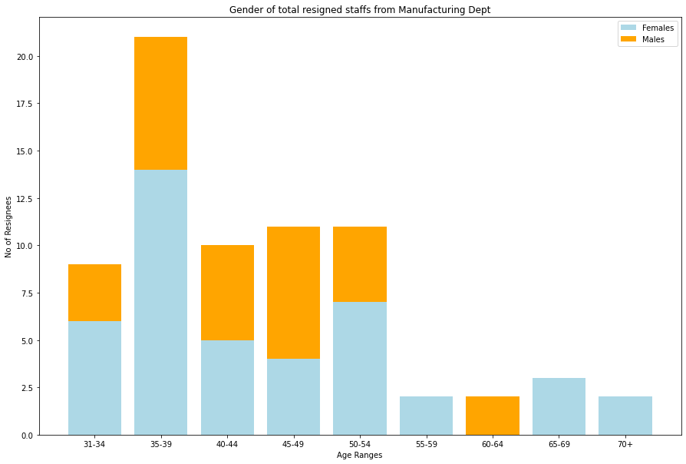

Question 1(C)

TO REPLACE “NaN”

(IPYNB file reference :-
"C:\Users\user\OneDrive - SUSS University\SUSS\ANL252\TMA_Question 1(C)_Replace NaN with date 1st May 2022.ipynb")

import pandas as pd
df = pd.read_csv (r'C:\Users\user\OneDrive - SUSS University\SUSS\ANL252\TMA_Data (Orginal 2).csv')
df.head()

import numpy as np
print(df.fillna("5/1/2022"))

TO DETERMINE YEARS OF SERVICE

(IPYNB file reference :-
"C:\Users\user\OneDrive - SUSS University\SUSS\ANL252\TMA_ANL252_Tan Boon May_W2210814_QUESTION 1C_YEARS OF SERVICE (final).ipynb")

import pandas as pd
df = pd.read_csv(r'C:\Users\user\OneDrive - SUSS University\Desktop\TMA_Data _CSV.csv')
df.head()

import pandas as pd
data = pd.read_csv (r'C:\Users\user\OneDrive - SUSS University\Desktop\TMA_Data _CSV.csv')
df=pd.DataFrame(data, columns = ['JoinDate', 'LeftDate'])
df.head()

from datetime import datetime
yearsofsvc = round((data['LeftDate'] - data['JoinDate'])/pd.Timedalta('365days').1)
df.head()

Input In [8]
yearsofsvc = round((data['LeftDate'] - data['JoinDate'])/pd.Timedalta('365days').1)
^
SyntaxError: invalid syntax

MINIMUM, MAXIMUM AND AVERAGE LENGTH OF SERVICE

(IPYNB file reference :-
"C:\Users\user\OneDrive - SUSS University\SUSS\ANL252\TMA_ANL252_Tan Boon May_ W2210814_QUESTION 1C_LENGTH OF SERVICE ASCENDING_DECENDING_MEAN(FINAL).ipynb")

import pandas as pd
data = pd.read_csv(r'C:\Users\user\OneDrive - SUSS University\Desktop\TMA_Data_length of service_accending(final).csv')
data.head()

Lengthofservice = data.sort_values(by='Length of service',ascending=True)
Lengthofservice.head(250)

Lengthofservice = data.sort_values(by='Length of service',ascending=False)
Lengthofservice.head(250)

Question 1(D)

(IPYNB file reference :-
"C:\Users\user\OneDrive - SUSS University\SUSS\ANL252\TMA_ANL252_Tan Boon May_ W2210814_QUESTION 1D (final)].ipynb")

from sys import exit

def enqury_staffname():
print("Good day, may I know the full name of the person you are looking for?")
Name = input("> ")

if Name == "staff_existing":
print("Sure, would you like to leave down your referred form of contact so that I could ask him/her to contact you? Yes/ No")
choice = input(">")

if choice == "Yes":
contact("> ")
print("Thank you for your info, I will get him/her to contact you within 2 working days. Good day.")
exit(0)

else choice =="No" :
print("Do you have any new query? Yes/No?")

choice2 = input(">")
if choice2 == "Yes":
print("Noted with thanks, I will bring you back to the main menu.")

else:
print("Thank you for your enqury, have a nice day")
exit(0)

elif Name == "staff_resgined":
print("Sorry, he/she is no longer working with our company. Do you have any new query? Yes/No?")

choice3 = input (">")
if choice3 == "Yes":
print("Noted with thanks, I will bring you back to the main menu.")

else:
print("Thank you for your enqury, have a nice day")
exit(0)

